**DAILY ONLINE ACTIVITIES SUMMARY**

|  |  |  |  |  |  |  |  |  |
| --- | --- | --- | --- | --- | --- | --- | --- | --- |
| **Date:** | **26/05/2020** | | | | | **Name:** | **Archana J C** | |
| **Sem & Sec** | **4th**  **‘A’** | | | | | **USN:** | **4AL18CS011** | |
| **Online Test Summary** | | | | | | | | |
| **Subject** | | **Data analysis and algorothm** | | | | | | |
| **Max. Marks** | | **30** | | **Score** | | | **26** | |
| **Certification Course Summary** | | | | | | | | |
| **Course** | **Java tutorial for beginners** | | | | | | | |
| **Certificate Provider** | | | **No certificate** | | **Duration** | | | **14 hours** |
| **Coding Challenges** | | | | | | | | |
|  | | | | | | | | |
| **Status: Completed** | | | | | | | | |
| **Uploaded the report in Github** | | | | | **Yes** | | | |
| **If yes Repository name** | | | | | **archana_j_c** | | | |
| **Uploaded the report in slack** | | | | | **Yes** | | | |

Online Test Details: (Attach the snapshot and briefly write the report for the same)

The online test is from data analysis and algorithm module 2. Which is about divide and conquer, binary search, quick sort, stassen’s matrix multiplication, topological sort etc…The test was conducted for 30 marks, duration is 45 minutes. I was scored 26/30.

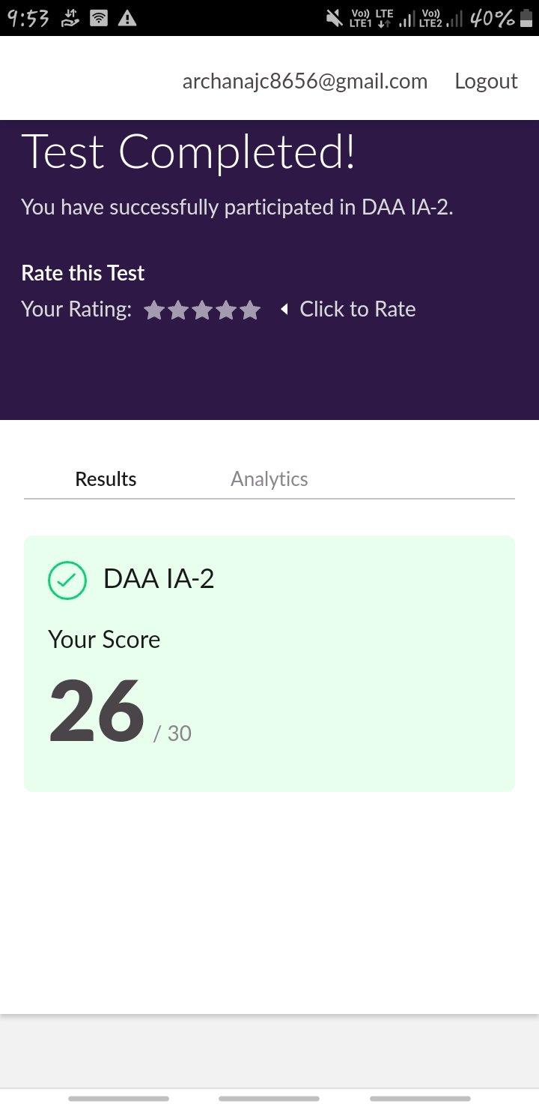

Certification Course Details: (Attach the snapshot and briefly write the report for the same)

COURSE NAME : Java for beginners

CERTIFICATION PROVIDERS : udemy

Today I leant about the introduction of java, how to install eclipse, jdk. What is java and how it works, and some of the examples on java programming.

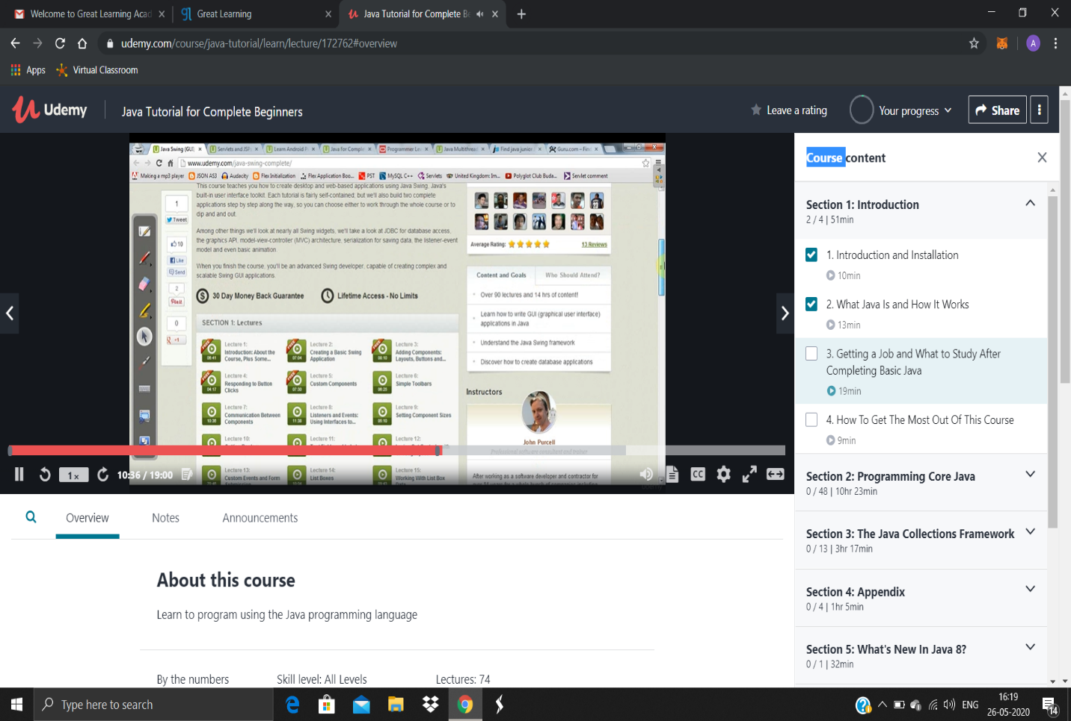

Coding Challenges Details: (Attach the snapshot and briefly write the report for the same)

Today I’m done with some c programs. The solution are already uploaded in github repository

PROBLEM : Write a program in C to print all permutations of a given string using pointers.

